Database model

Model
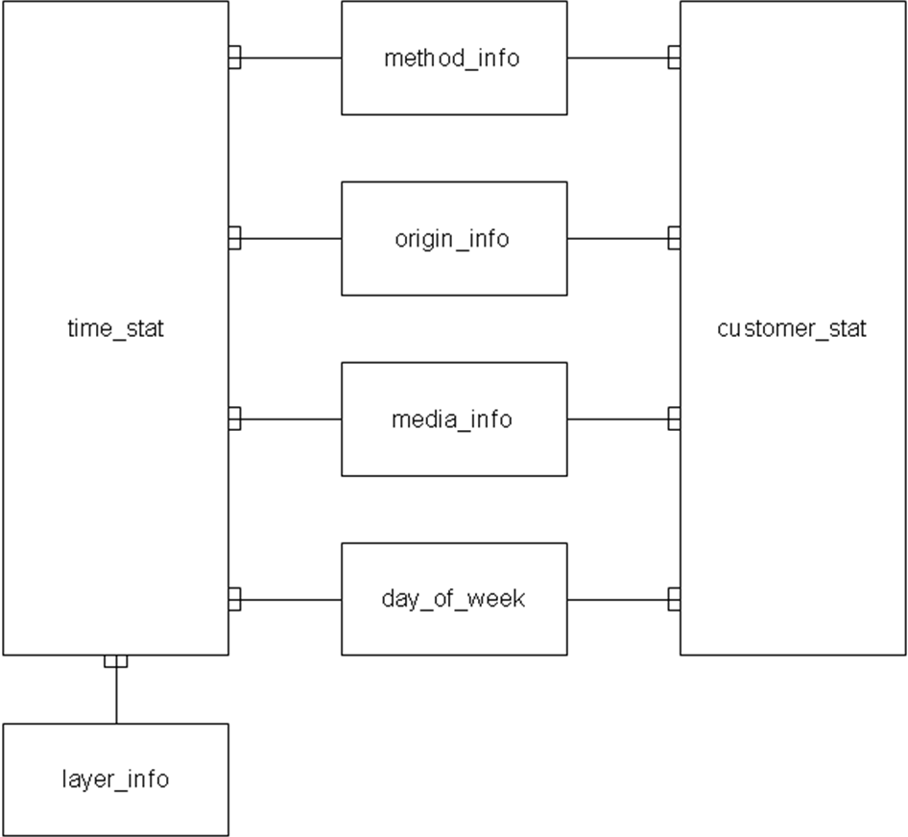

method_info
Column | Type | Description
method_id* | NUMBER(9), not null | Id for the method.
service_name | VARCHAR2(100), not null | The name of the service.
method_name | VARCHAR2(100), not null | The name of the method.

layer_info
Column | Type | Description
layer_id* | NUMBER(9), not null | Id for the layer.
layer_name | VARCHAR2(30), not null | The name of the layer.

origin_info
Column | Type | Description
origin_id* | NUMBER(9), not null | Id for the origin.
origin_name | VARCHAR2(30), not null | The name of the origin (calling, application, for example “SMS” and “Ta en UC” uses UCOrders2).

media_info
Column | Type | Description
media_id* | NUMBER(9), not null | Id for the media.
media_name | VARCHAR2(50), not null | The name of the media.

day_of_week
Column | Type | Description
day_of_week_id* | NUMBER(1), not null | Id for the day of the week.
day_of_week_name | VARCHAR2(10), not null | The name of the day
Immutable table with the following records:
0: Måndag
1: Tisdag
2: Onsdag
3: Torsdag
4: Fredag
5: Lördag
6: Söndag

customer_stat
Column | Type | Description
method_id* | NUMBER(9), not null | Id for the method. Reference to method_info.
origin_id* | NUMBER(9), not null | Id for the origin. Reference to origin_info.
media_id* | NUMBER(9), not null | Id for the media. Reference to media_info.
product* | CHAR(20), not null | The name or id of the product.
customer* | CHAR(50), not null | The name or id of the customer.
statistics_date* | DATE, not null | The date for the statistics. This field has the hours, minutes and seconds set to 0.
day_of_week_id | NUMBER(1), not null | The day of the week. Reference to day_of_week.
num_correct_calls | NUMBER(9), not null | The number of correct calls performed.
num_invalid_calls | NUMBER(9), not null | The number of invalid calls. An invalid call is a call which fails in a predicted way, for example because of invalid input from the client.
num_failed_calls | NUMBER(9), not null | The number of failed calls. A failed call is a call failing for technical or unpredicted reasons, for example because a database does not respond or because of a NullPointerException.
Product is today usually the 3-digit UC-type, for example 410. However, this model is done to allow other product definitions in the future which are the reason for limiting the length to 20 characters.
Customer is today usually the 5-character customer id. However, this model is done to allow other ids in the future when IAM is in place and for example SMB is in place with a new customer system which are the reason for limiting the length to 50 characters where most mail addresses will fit in.

time_stat
Column | Type | Description
method_id* | NUMBER(9), not null | Id for the method. Reference to method_info.
origin_id* | NUMBER(9), not null | Id for the origin. Reference to origin_info.
media_id* | NUMBER(9), not null | Id for the media. Reference to media_info.
layer_id* | NUMBER(9), not null | Id for the layer. Reference to layer_info.
product* | CHAR(20), not null | The name or id of the product.
statistics_time* | DATE, not null | The date for the statistics. This field has the minutes and seconds set to 0.
day_of_week_id | NUMBER(1), not null | The day of the week. Reference to day_of_week.
hour_of_day | NUMBER(2), not null | The hour of the day. 0-23.
num_correct_calls | NUMBER(9), not null | The number of correct calls performed.
num_invalid_calls | NUMBER(9), not null | The number of invalid calls. An invalid call is a call which fails in a predicted way, for example because of invalid input from the client.
num_failed_calls | NUMBER(9), not null | The number of failed calls. A failed call is a call failing for technical or unpredicted reasons, for example because a database does not respond or because of a NullPointerException.
total_time_correct_calls | NUMBER(18), not null | The total number of milliseconds for all correct calls.
total_time_invalid_calls | NUMBER(18), not null | The total number of milliseconds for all invalid calls.
total_time_failed_calls | NUMBER(18), not null | The total number of milliseconds for all failed calls.
num_10 | NUMBER(9), not null | The number of calls taking 0-10 milliseconds.
num_20 | NUMBER(9), not null | The number of calls taking 11-20 milliseconds.
num_50 | NUMBER(9), not null | The number of calls taking 21-50 milliseconds.
num_100 | NUMBER(9), not null | The number of calls taking 51-100 milliseconds.
num_200 | NUMBER(9), not null | The number of calls taking 101-200 milliseconds.
num_500 | NUMBER(9), not null | The number of calls taking 201-500 milliseconds.
num_1000 | NUMBER(9), not null | The number of calls taking 501-1000 milliseconds.
num_2000 | NUMBER(9), not null | The number of calls taking 1001-2000 milliseconds.
num_5000 | NUMBER(9), not null | The number of calls taking 2001-5000 milliseconds.
num_10000 | NUMBER(9), not null | The number of calls taking 5001-10000 milliseconds.
num_20000 | NUMBER(9), not null | The number of calls taking 10001-20000 milliseconds.
num_over_20000 | NUMBER(9), not null | The number of calls taking 20001 milliseconds and above.
Product is today usually the 3-digit UC-type, for example 410. However, this model is done to allow other product definitions in the future which are the reason for limiting the length to 20 characters.

